Describe a situation when you laughed a lot:

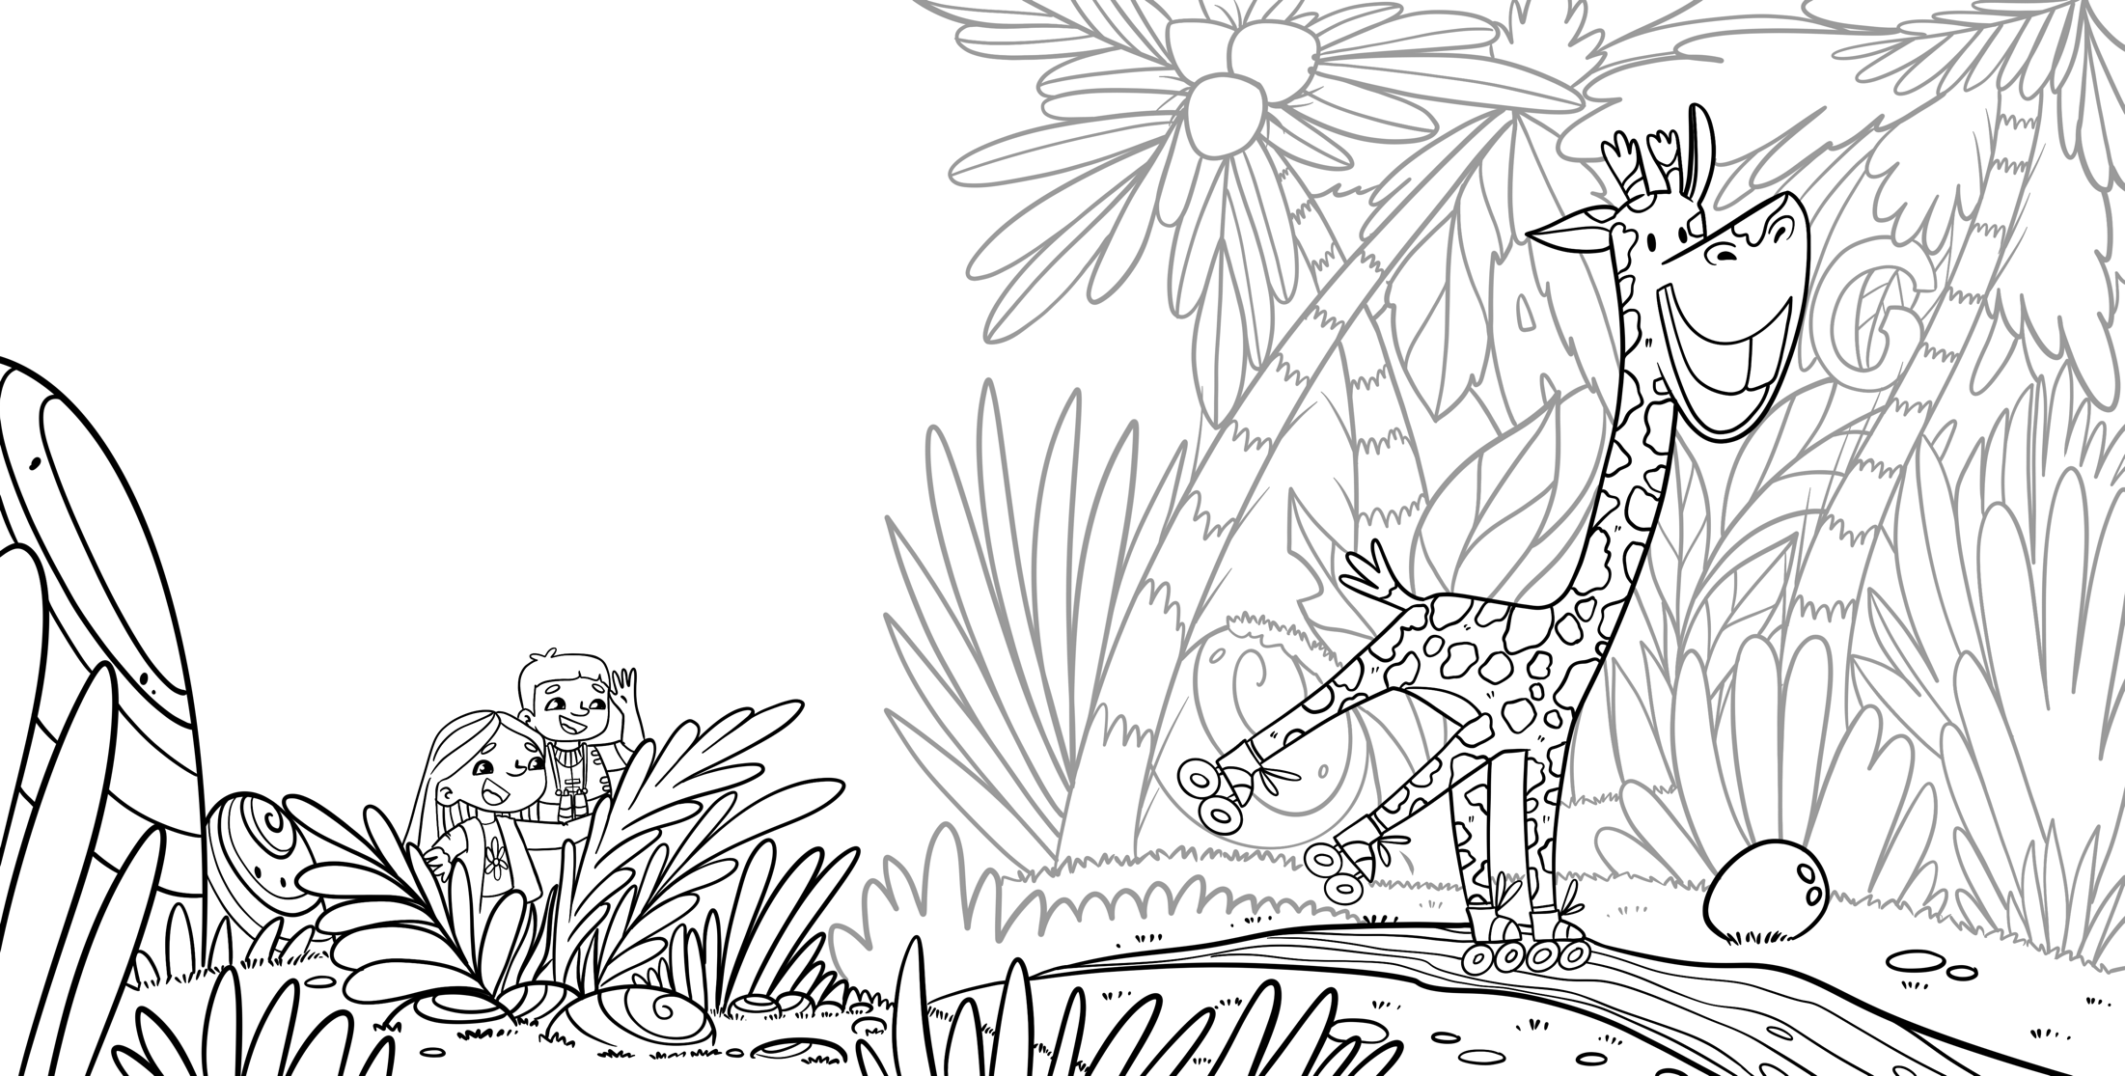
Describe a situation when you needed to think hard:

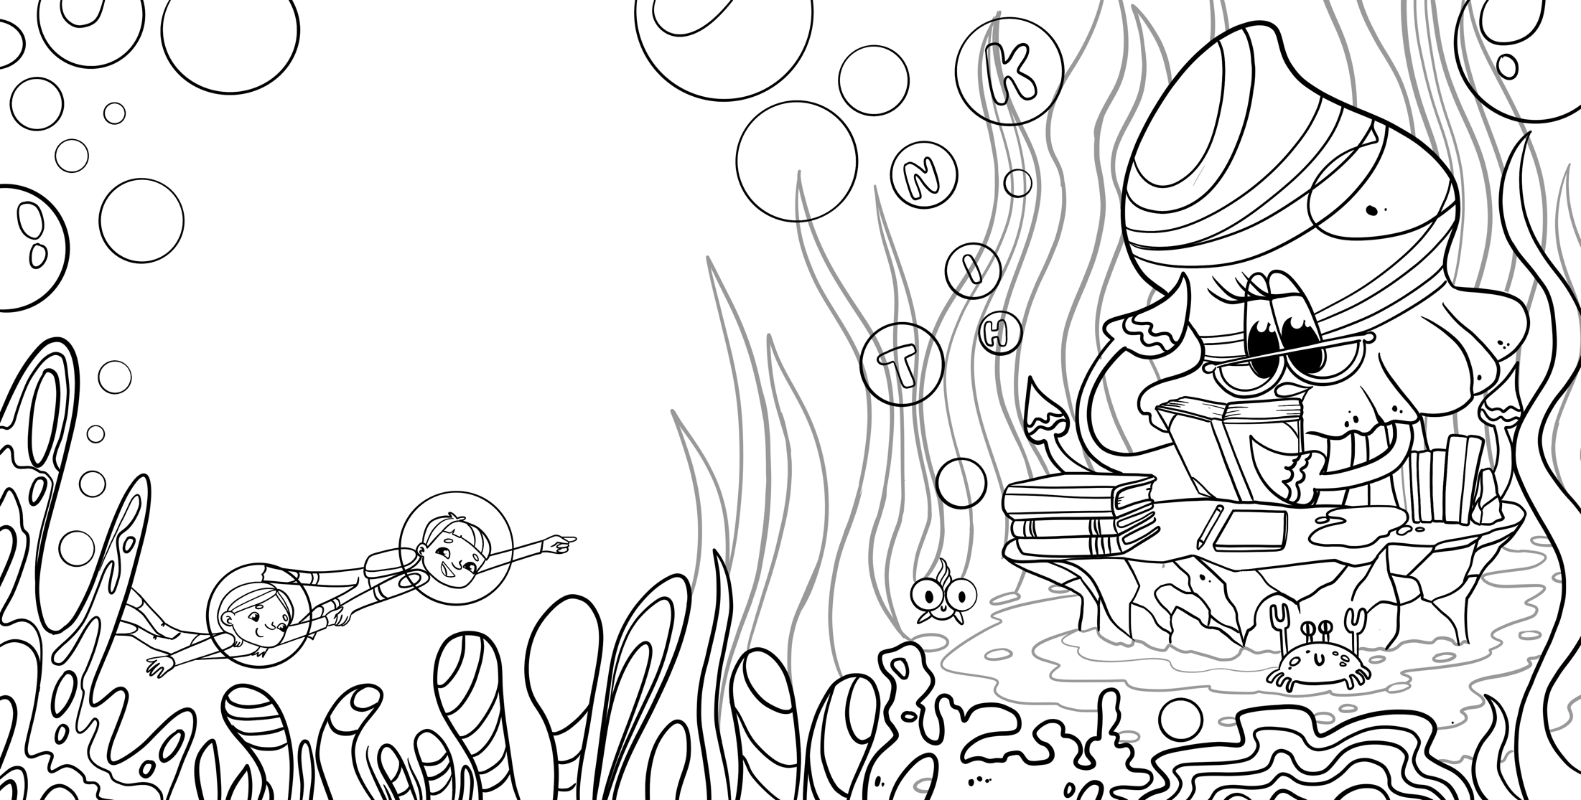

Describe a situation where you helped others:

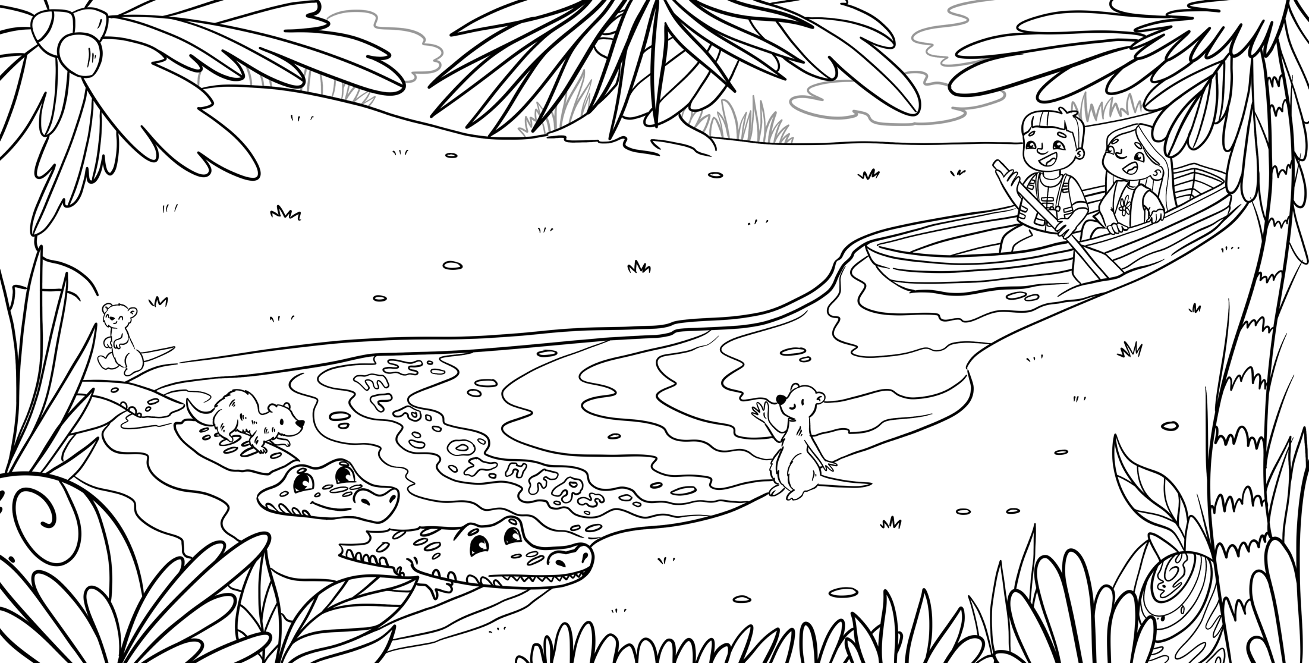

Describe a situation where you respected others:

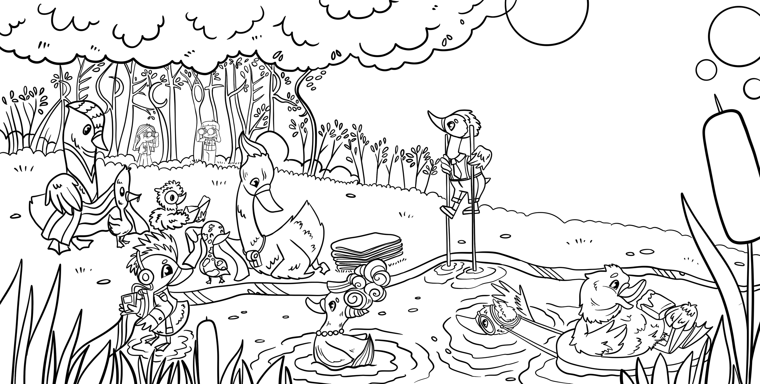

Describe a situation where you needed to be tough:

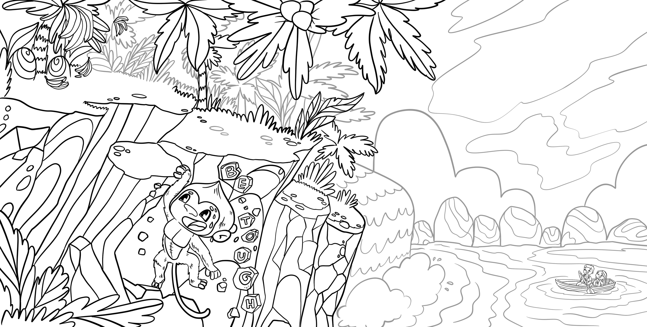

Describe a situation where you didn’t achieve what you wanted, but did your best:

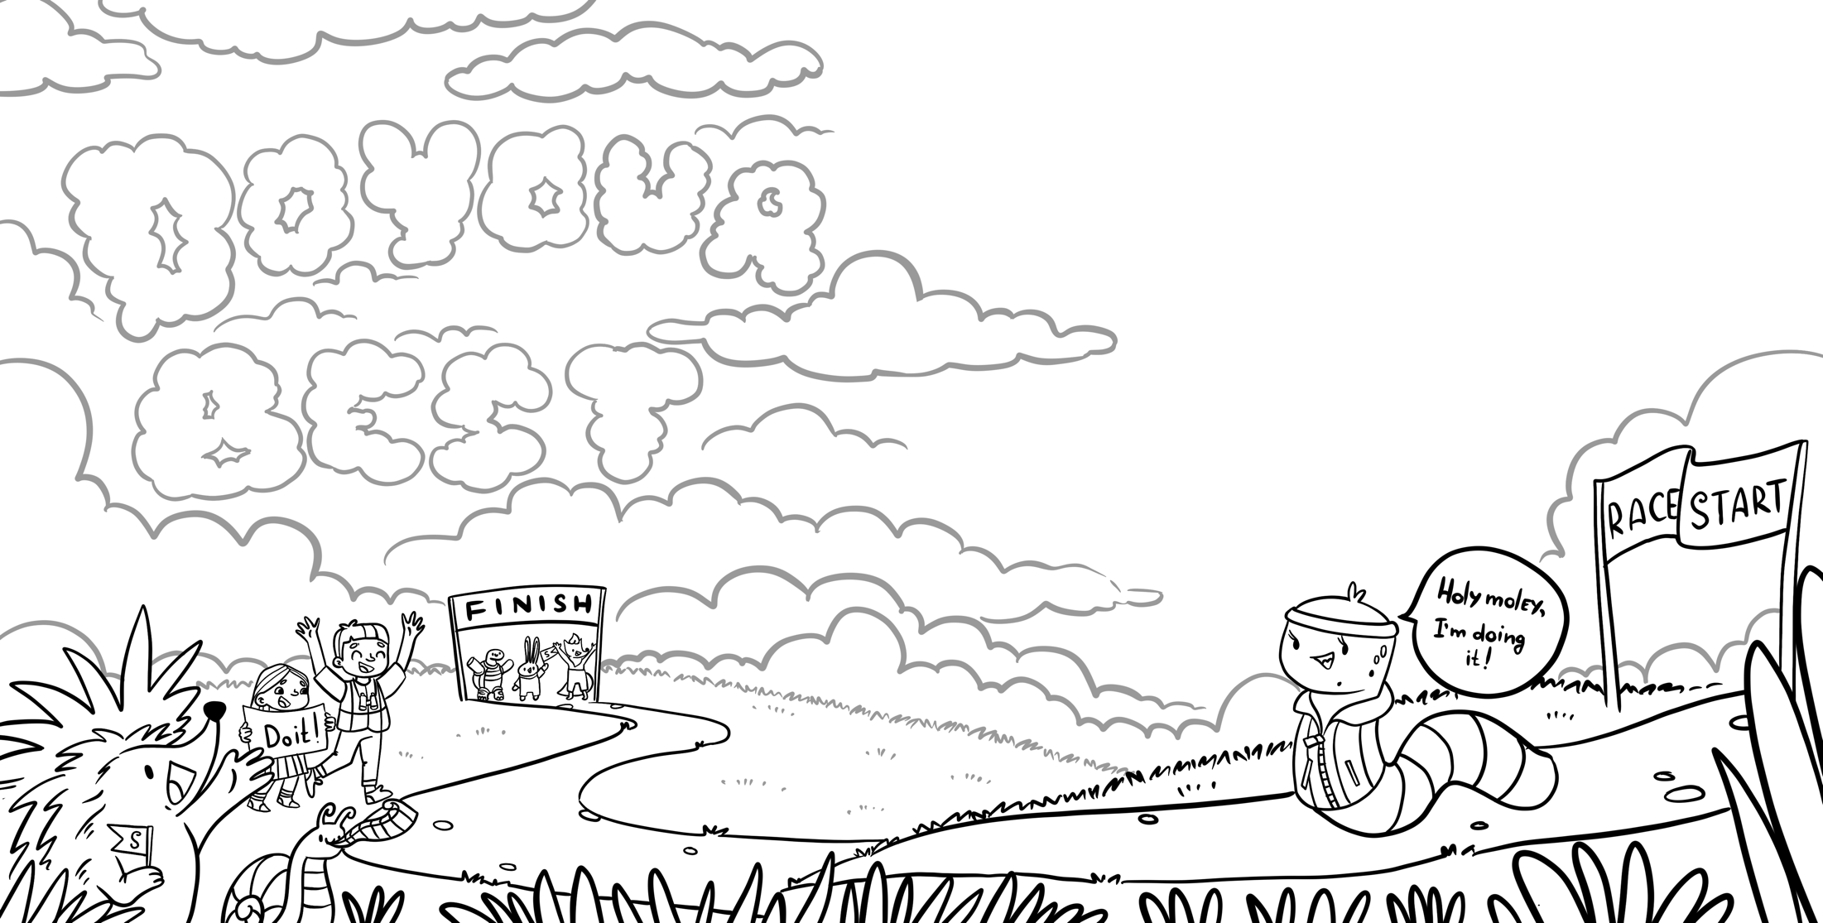

Describe 3 things you are grateful for:

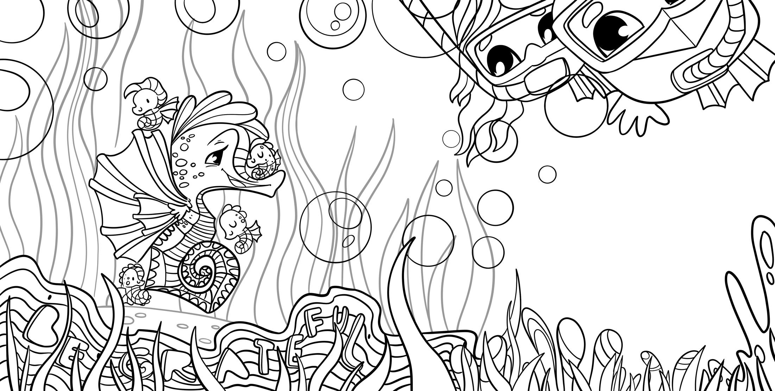

Describe a situation where you hustled:

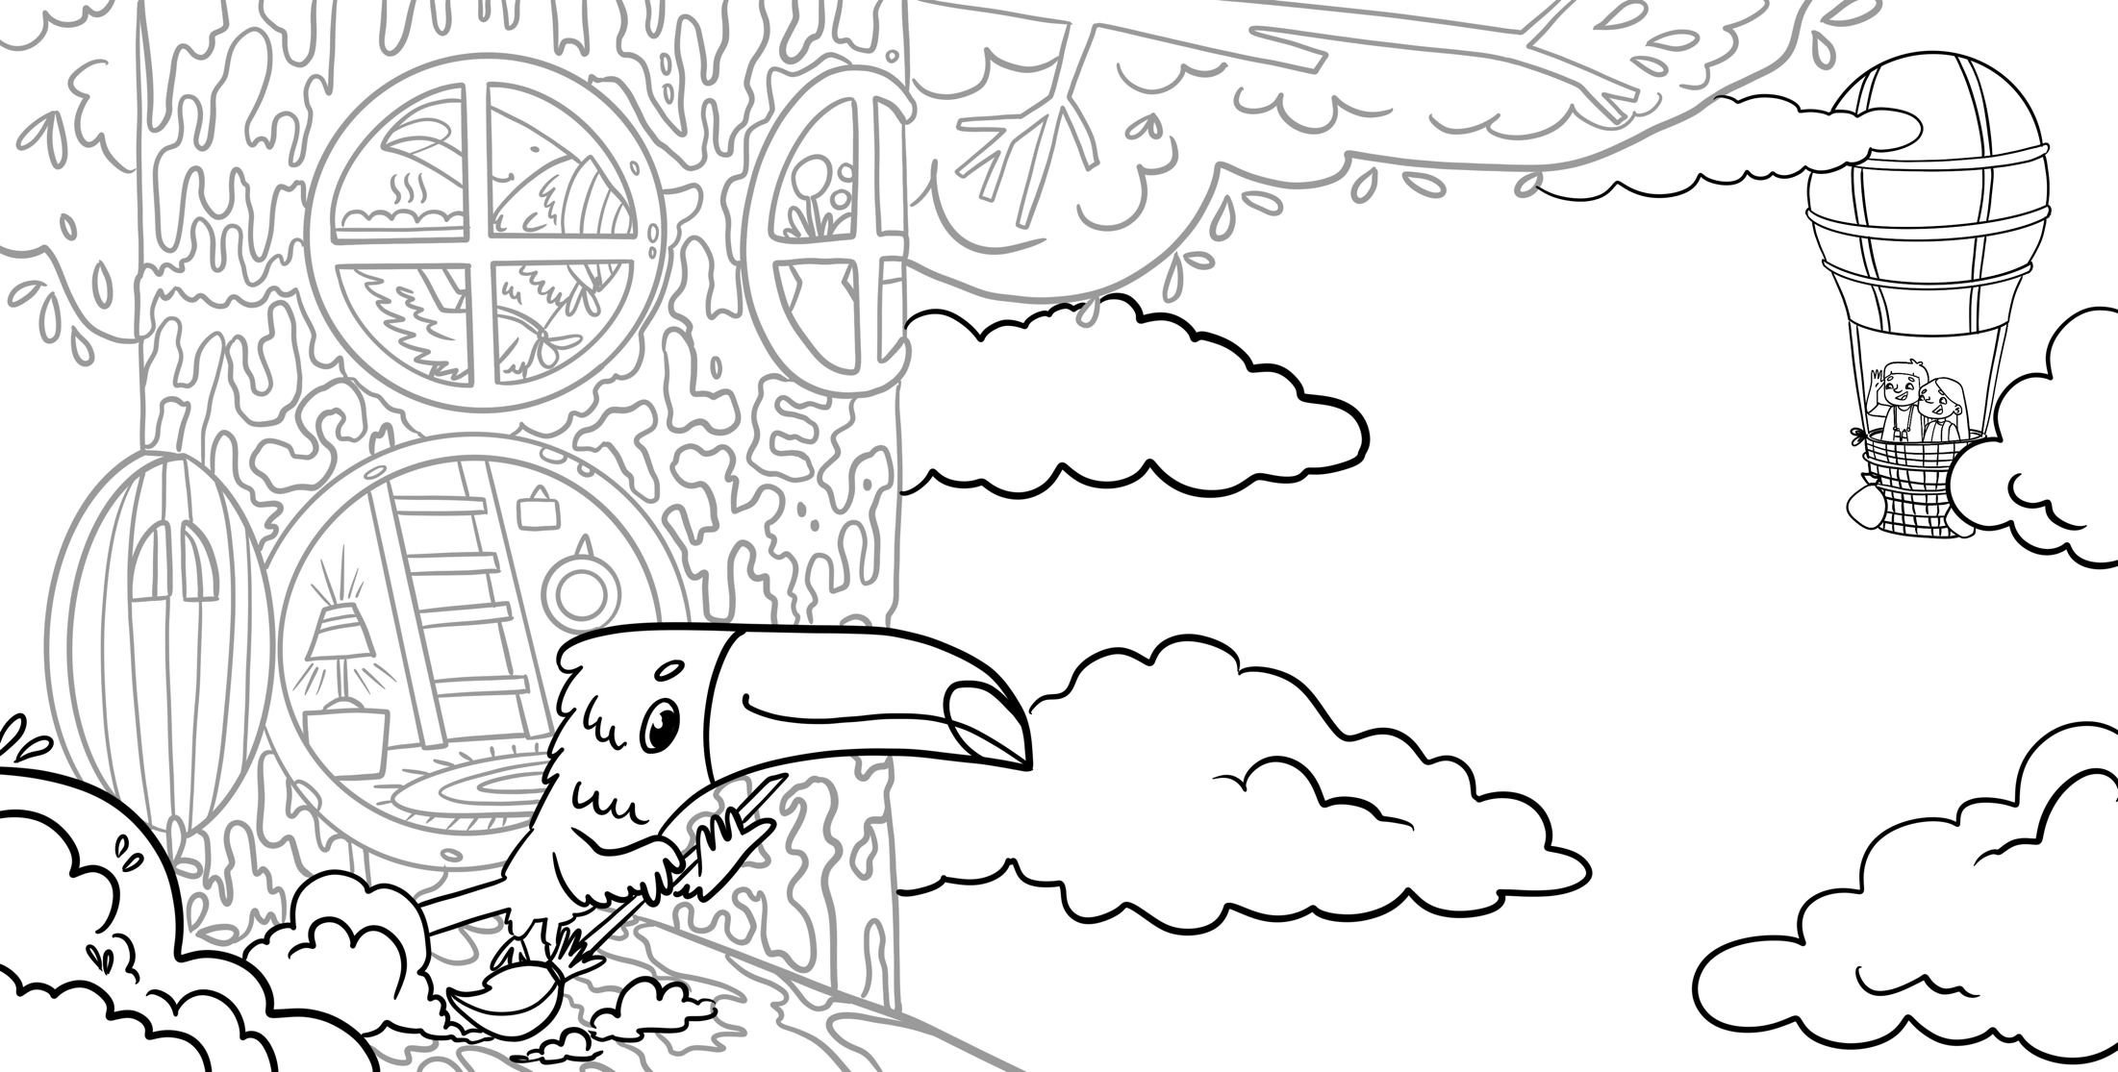

Describe a situation where you felt courageous enough to say no:

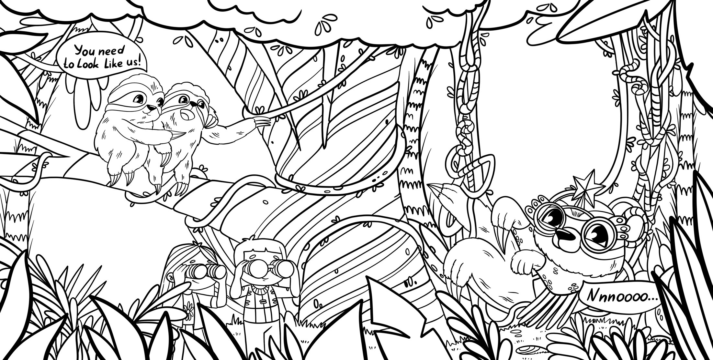

Do you remember a situation when you could really focus on the moment, and on everything that was going on in that moment?

